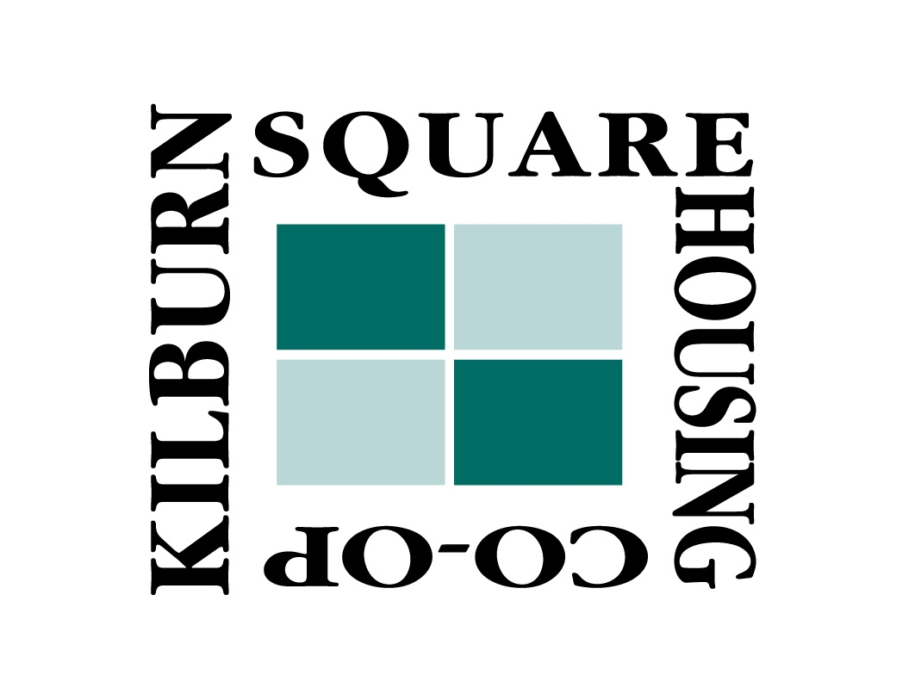

**Kilburn Square Housing Co-op**

**Business Plan 2017-2022**

**Contents**

1. Executive Summary ……………..………………………………..... 3
2. Introduction and background ………………………………..... 4
3. Vision, Values and Objectives ……………………………….... 7
4. Strategies and Action Plans ………………………................ 9
5. Finance and Risk Management Plan ……………………….. 12
6. **Executive summary**

Kilburn Square Housing Co-operative (KSHC) sets out our plans and visions for the future. We are a not for profit organisation, a registered society under the Co-operative and Community Benefit Act 2014 and any surpluses made by KSHC prudent management will be used and applied back in the estate for the benefit of all our residents. KSHC has a healthy bank balance due to our careful management over the years.

KSHC Board will be facing many challenges in future years on our allowances and the income KSHC receive from the council. The KSHC board will be looking to find new business opportunities to replace the reduction of allowances to enable us to keep and maintain the high standard of management and services the residents of KSHC receive.

KSHC is a member of the National Federation of Tenant Management Organisations (NFTMO) and hold a seat on the executive committee, who discuss at a national level issues concerning Tenant Management Organisations (TMO).

In 2017 KSHC will be negotiating a new Modular Maintenance Agreement (MMA) with the Brent Housing Partnership (BHP)/Brent Council.

KSHC philosophy is to achieve best value in all areas, by continuing to look at our services and procedures, consulting our stakeholders and to be focused to improve our performance to ensure delivery of a quality service to our estate and the wider community.

Margaret Von Stoll

Chair

1. **Introduction and background**
   1. About our TMO and our business plan

Kilburn Square Housing Co-op is a limited company registered with the Financial Services Authority as an Industrial and Provident Society (Registration number IP27573R). It was set up in 1994 as a Tenant Management Organisation governed in line with the Right to Manage Legislation. We have a legally binding contract with Brent Council: a Modular Management Agreement which sets out our role and responsibilities as well as the Council’s role and responsibilities. We celebrate 25 years of operation as a Co-op in 2017.

The TMO manages 246 properties of which approximately 30% are leaseholder properties. KSHC is an open and democratically run organisation, governed by a Management Board made up of residents who sit as volunteer Directors that are responsible for the strategic delivery of all undertakings. All residents with a legal entitlement to live on the estate are entitled to become Members and to participate in the decision-making processes of the TMO.

The Board is supported by a dedicated staff team based in Kilburn Square, London, NW6 6PT, who are employed to deliver the day to day work and services for the estate. The Estate Manager reports monthly to the Board and is in charge of a team comprising a Housing Officer, a Finance Officer, a Maintenance Officer, a Security and Front Desk Coordinator, plus three caretakers.

The business plan sets our analysis of the current situation, including what we have achieved so far and where we feel there may be room for improvement. Our business plan also sets out our vision, mission, values and strategic priorities for the next 5 years. The business plan shows what we are aiming to achieve overall and covers the services that we provide, by identifying issues relating to how we run the TMO, how we involve the community and the way we run our organisation. Finance is critical and we have clear objectives and strategies to ensure that we provide a quality service in the most efficient way and that we manage our finances successfully. Finally, we have included a series of actions. These actions show how we will go about turning our vision into reality.

* 1. About our community and neighbourhood

KSHC is located in the London Borough of Brent. The TMO is in the heart of Kilburn, a stone’s throw off the high street. The estate is made up of a 17-storey tower block built in the late 1960s and four low-rise buildings of 6 or 7 floors. There is a large playground area and a number of gardens. Our community is very ethnically diverse and there is a mixture of families, all generations and people from different cultural backgrounds.

* 1. Background

KSHC was set up in 1992 with the help of Section 16 agent Catch. The TMO was founded by a group of residents who wanted to find a better solution to the increasing housing and security issues due also to the estate being situated in close proximity to a high street very busy during the day and also at night. The TMO improved the security on the estate with extra lighting and employing security staff, installing door entry systems, CCTV cameras and perimeter gates on the boundaries of the estate. The TMO created a large community room used for business, meetings and events. The green areas as well as the play and football facilities were improved for the benefit of the estate children.

* 1. Partners and Stakeholders

Brent Council set up an Arm Length Management Organisation (ALMO), Brent Housing Partnership (BHP), in 2002. BHP is responsible for the client monitoring aspects of the two TMOs that are currently in operation in Brent (Kilburn Square Housing Co-op and Watling Gardens). The TMOs represent a very small proportion of properties in Brent that have a designated team that supports and monitors the functions of the TMOs. The TMO and BHP have a good working relationship.

The other key stakeholders are the estate residents, both tenants and leaseholders.

* 1. Services provided

The services provided by the TMO are defined in the MMA with the London Borough of Brent, which sets out the TMO’s responsibilities and those services which the Council has retained responsibility for.

The TMO manages responsive repairs, voids, housing management services, rent arrears collection, cleaning, grounds maintenance, trees, security (gates, door entry system and CCTV) and community development.

The Council retained services are heating and hot water (boilers), gas servicing, lifts, roofs, external building structure, major voids, main drainage, planned cyclical maintenance and major works.

The TMO manages possession proceedings using the Council’s legal services to undertake court action. All vacant properties are offered to people on Brent Council’s housing and transfer lists. The TMO operates an internal transfer list. In order for residents to be put on the internal transfer list they have to have to complete the Council’s transfer application.

* 1. Successes to date and key plans for the future

Being a TMO has made a real difference for the tenants and leaseholders of Kilburn Square and has significantly improved the standard of the services provided to the residents and their quality of life.

There is an on-site office for residents and contractors. Having its own staff who know the people on the estate, including vulnerable tenants, has been key for the TMO. Residents receive speedy repairs by the in-house Maintenance Officer who, over the years, has gained a clear understanding of all the issues related to the building complex, leading to good value for money and also to better Key Performance Indicators (KPIs) in areas such as rent collection, responsive repairs and complaints handling compared to the properties directly managed by the Council.

Residents know that they have the option to join the Board and have their say in how the estate is run. Holding estate functions and activities help bring the community together. There are a number of social activities provided by the Co-op such as coach trips, BBQs, table top sales, special events and weekly bingo. As a result of this enhanced sense of community, Anti-Social Behaviour has been greatly reduced with positive externalities to the broader neighbourhood.

The TMO has also reflected on its Strengths, Weaknesses, Opportunities and Threats (SWOT) facing the organisation. This SWOT analysis has been used to assess the TMO’s objectives, strategies and risks.

|  |  |
| --- | --- |
| **Strengths** | **Weaknesses** |
| Committed Management Board and experienced operational team.  Prudent financial management and monitoring systems in place.  Strong service delivery performance.  Good programme of community activity.  Good knowledge of our properties and our community.  Good track record of delivering services and projects on the estate.  Good relationship with key stakeholders. | A relatively small organisation, with possible diseconomies of scale.  Board not having the right skills to operate the TMO, comprehensive training programme to be developed.  Board lack of understanding around Governance and the MMA.  Board lack of understanding around budgets/finance.  Board being more business minded and understanding the implications of not managing Governance effectively.  Board to ensure minutes are concise and accurately recorded.  Tenants to be involved in consultation on all service improvement on the estate. |
| **Bo** | **Threats** |
| Increase the number of properties we manage.  Look the possibility of merging the two TMO’s.  Delivering more social related activities within the community.  Increasing membership and levels of engagement.  Developing a wide range of community support.  Opportunities to work with a wider range of partners including the Council and local schools and workshops. | Housing and Planning Bill.  Potential reductions to future income steam.  Lack of support for the continuation of the TMO.  Lack of funding for capital investment.  Complacency amongst residents and members leading to inactivity.  Impact of Universal Credit on residents and TMO income collection.  Failure to meet Governance means the termination of the MMA. |

1. **Vision, Values and Objectives**
   1. Our Vision

KSHC is committed to working for the people of the estate and with organisations in order to provide excellent services and improve the quality of life for our residents through tenant management and community empowerment. Our aim is to make the estate a safe, clean and green place to live and ensure that our community is vibrant, friendly and respectful. We will achieve this by:

* Providing the best housing service possible for our residents.
* Ensuring we continue to communicate, consult and involve all members of our community in the TMO and local decision making.
* Improving the homes and estate for our residents.
* Undertaking projects and initiatives which will benefit our residents and local people.
* Working with other groups and the council to improve a wide range of services for our residents.
* Being self-aware and striving to improve our services.

Our mission is to deliver excellent services through resident-led management.

* 1. Our Values

KSHC has adopted the following values in order to reflect our commitment to providing excellent services and the empowerment of our residents and local people:

* We respect our community and care about people and as a TMO we strive to make a difference
* We celebrate the diversity of our community and will strive to ensure we represent and serve all of our residents in a fair and equitable manner.
* Our residents are our customers and their contribution to the TMO is key to our success.
* We value of staff and seek to be a good employer.
  1. Our Key Objectives
     1. *Community objectives*

The TMO has contributed positively to the community and we want our residents to stay with us for a long time. We have seen an increase in people exercising the Right-to-Buy which we believe is as a result of the work that the TMO has done. We want to keep holding regular social events that are well attended. We are forever seeking new ways of engaging with our community and the Board reflects a good representation of the residents that live on the estate.

We want to invest in the community, especially younger residents, via apprenticeship schemes and we want to develop new activities for senior residents.

* + 1. *Organisation & governance objectives*

We are improving a new governance framework, which is being developed and adopted by the Board. The governance structure in place helps us manage the organisation and gives us clear outline to roles and responsibilities. We have monthly Board meetings, one Annual General Meeting (AGM) and three General Meetings. We consult and keep our stakeholders informed on a monthly basis. Policies are currently reviewed and adopted as necessary, usually every two years. Relevant changes are discussed and debated at the meetings and voted upon when necessary to allow us to be open and transparent. We want to increase the number of Board Members and prioritise training for all of them.

* + 1. *Services and project objectives*

We want to develop a service to increase security at the site, i.e. identify a better way to patrol the estate outside regular office hours (overnight and weekends).

We want to improve IT digital services for both residents and the Board.

We want to take over the management of the new build on the Rathbone Garage side and to take over more Council street properties.

We propose to introduce repairs or works for leaseholders by an in-house Maintenance Officer who knows the estate. This will deliver best value for money as well as bring new revenue to KSHC.

We plan to send out questionnaires for residents’ satisfaction and feedback, in order to obtain proposals to improve the services provided, considering the whole life cycle cost and seek best value for money, which may not necessarily be the cheapest option in the short term.

* + 1. *Financial objectives*

We receive an allowance from the Council, administered by Brent Housing Partnership (BHP), which should be equivalent to what it costs BHP to manage the Council’s housing stock, in accordance with a formula set by the government in the Right to Manage Legislation.

Should the TMO be prudent and make a surplus i.e. provides services at a lower cost, we want to use the surplus to carry out improvements on our estate, following full consultation with our Members.

We endeavour to achieve ‘value for money’, which ensures the TMO is efficient and that risk will be managed.

We plan to set our budget before the end of the financial year and to consult regularly with the Estate Manager and the Finance Officer in order to monitor our finances every month.

We want to ensure that all finance reports and associated papers are submitted in a user-friendly format.

1. **Strategies and Action Plans**

KSHC has set the key objectives for the period 2017-2022 in Paragraph 3.3 of this Business Plan. In this Section 4 we detail how we plan to turn words into actions and how we intend to identify what needs to be done and where to direct our efforts.

In particular, the following tables capture the key strategies and actions targeted at achieving our strategic objectives. By setting targets we will have something to aim for and we will be able to measure our performance and achievements. Each target has been selected according to the SMART criteria:

**S**PECIFIC: the target is clear and precise.

**M**EASURABLE: we will be able to measure whatever we are trying to achieve.

**A**CHIEVABLE: while targets should be challenging they should also be attainable.

**R**ELEVANT: targets are consistent with the objectives and strategies.

**T**IME FRAMED: actions and targets have a date by which they need to be achieved.

The Board will oversee and monitor the action plans designed to ensure that the TMO can realise these objectives.

|  |  |
| --- | --- |
| **IMPLEMENTATION PLANNING (STRATEGIC LEVEL)** | |
|  | |
| **4.1 Community strategy – Improve and create a positive, welcoming and healthy community** | |
| *STRATEGY* | *KEY ACTIONS* |
| Develop and implement a communications strategy by December 2018. | Map out the TMOs stakeholders.  Liaise with stakeholders to establish their priorities and plans relating to the estate.  Monthly newsletters; block letters and flyers; better use of website. |
| Bring innovative services to the estate which promote health & wellbeing. | Work in partnership with local healthcare partners to map out community needs and promote health initiatives.  Invest in apprenticeship schemes for young residents and develop new activities for the elder. |
| Continuously raise the level of awareness of the TMO and its services with key stakeholders. | Complete stakeholder mapping.  Undertake liaison visits with key stakeholders. |
| To improve awareness of the TMO’s provision to ensure residents recognition of its services – complete survey of estate residents by December 2018. | Undertake survey of estate residents.  Undertake questionnaire survey to establish resident’s awareness of TMO and Council provided services. |
|  | |
| **4.2 Organisation & governance strategy – Maintain a strong, strategically focused board, providing clear leadership and direction** | |
| *STRATEGY* | *KEY ACTIONS* |
| Ensure the Management Board is well supported and informed – undertaking an annual self-assessment by Board Members in September annually. | Complete board member self-assessment to establish ‘gap analysis’ against key capabilities. |
| Improve board capacity, knowledge and experience through training and skills development. | Undertake individual and board-wide training needs analysis.  Ensure all board members have completed training and development plans.  Advertise training opportunities to board members.  Monitor training spend as part of the financial reporting cycle to the board. |
| Ensure the TMO is constantly aware of its environment and with access to information that allows it to make strategic decisions – undertaking an annual self-assessment by Board members in September annually. | Complete board member self-assessment to establish ‘gap analysis’ against key strategic decision criteria. |
|  | |
| **4.3 Services and project strategy – Provide high quality and responsive services which are valued by all our residents** | |
| *STRATEGY* | *KEY ACTIONS* |
| Achieve satisfaction rate with the TMO’s responsive in house repairs service. | internal repair satisfaction survey completed with outcome reported to the board |
| Aim to reduce the level of reported anti-social behaviour on the estate by 10% in 2017/18 | Continue working with the safer neighbourhood teams and external partners/agencies the TMO works with alleviate ASB related issues on the estate.  Emphasise the TMO’s approach to ASB during the sign-up stage.  Meet target response times for each category of ASB. |
| Provide housing services that meet and continuously meet our resident’s expectations. | Undertake annual surveys of service users.  Correspondence response within 10 working days; |
| Improve the access to estate services through the use of the web, texting, email, aiming to achieve a minimum of 25% of service requests being raised through these channels by December 2018. | Undertake a feasibility study of texting.  Review the TMO website.  Report to Board quarterly on the channels used by residents to make service requests. |
| Aim to meet and exceed resident’s expectation on housing services provision yearly as outlined within the MMA and with reference to KPI standards. | Publicise KPI standards in newsletter and on notice boards.  Undertake ‘moving in’ reviews with new residents after 6 weeks of new tenancy starting to consult on satisfaction with TMO and the ‘moving in’ experience.  Consult on satisfaction with housing service provision in residents’ survey. |
| Increase the properties managed by the TMO by December 2019 and more subsequently. | Consult with neighbouring estates on Right to Manage Options. |
|  | |
| **4.4 Finance strategy – Drive down operational cost through efficient and innovative delivery strategies.** | |
| *STRATEGY* | *KEY ACTIONS* |
| Ensure the TMO achieves its annual projected surplus to build the TMO’s reserve fund target. | Establish an annual reserve fund target – monitored by the Board quarterly. |
| Continue to ensure the TMO is efficient and achieves value for money through all aspects of its operation. | Board to receive a quarterly report detailing the average cost of a basket of repairs. Board to develop a value for money policy. |
| Effective financial management and controls are in place to ensure financial plans are delivered. | Annual audit report to the board. |

1. **Finance and Risk Management Plan**
   1. Financial Projections

The TMO’s finances are projected to remain healthy throughout the period of the business plan. We expect the focus and profile of our spending to change over time, particularly as we start to reinvest the savings we make due to efficiency savings back into making improvements on the estate. In fact we expect our budget to maintain an annual underspend, which will of course be invested back into our community to bring about real improvements to our environment and communal spaces as well as internal improvements to properties.

The Co-op’s primary income is generated from the MMA allowances. There are also a number of non-core activity income streams, such as revenue generated by the car park permits and the meeting room’s hire, and the bank interests.

The TMO’s expenditure can be split between the resources spent on maintenance and on management. As an organisation, the TMO will work towards achieving ever greater efficiency by reducing future management costs while striving to deliver value for money in the repairs and maintenance function across the estate. We are keen to ensure our annual expenditure continues to be appropriately balanced between management and maintenance costs.

The area surrounding the estate continues to be regenerated and improved, including new housing developments on the fringes of Kilburn Square, which provide the TMO with the opportunity for expansion, bringing more homes under the management of local residents. We believe that a reduction in average costs may also derive from any future successful expansion plans through the acquisition of additional properties.

The breakdown of expenditure between management, maintenance and improvement works in the period covered by this business plan will vary year to year, however on average we predict that an estimated 55% of our annual expenditure will be dedicated to maintenance with approximately 30% spent on management, which is in line with the previous years. The remaining expenditure (15% on average) will be targeted at a range of improvement works. The following chart shows the expected breakdown between these areas of expenditure.

The table below outlines how we plan to invest future accumulated resources into the estate – these will take the form of capital/improvement spend on our estate and will be subjected to an annual review.

|  |  |  |  |  |  |
| --- | --- | --- | --- | --- | --- |
| **Expenditure projections for the**  **planned improvement works** | **2017/18** | **2018/19** | **2019/20** | **2020/21** | **2021/22** |
| Environmental improvements | £6,000 | £4,000 | £6,000 | £2,000 | £2,000 |
| Estate signage | £6,000 | - | £4,000 | - | £4,000 |
| Communal flooring upgrade for the Low Rise | £12,000 | £4,000 | £6,000 | £8,000 | £6,000 |
| Car park resurfacing next to the Tower Block | £6,000 | £12,000 | £4,000 | £4,000 | £8,000 |
| Communal bridge resurfacing | £6,000 | £4,000 | £12,000 | £8,000 | £4,000 |
| Bin enclosures | - | - | £6,000 | £2,000 | £4,000 |
| Bicycle stands | - | £6,000 | - | £4,000 | £4,000 |
| Fobs for all the estate pedestrian gates | £6,000 | £6,000 | - | £6,000 | £2,000 |
| After hours security / ASB issues | £4,000 | £4,000 | £2,000 | £6,000 | £4,000 |
| Security review (CCTV, gates, etc.) | £2,000 | £4,000 | £6,000 | £6,000 | £6,000 |
| Any other key Health & Safety issues | £2,000 | £6,000 | £4,000 | £4,000 | £6,000 |
| **Indicative annual provision** | **£50,000** | **£50,000** | **£50,000** | **£50,000** | **£50,000** |

* 1. Risks and issues

In setting out our strategic and operational objectives we have assessed the risks and issues we face and which may prevent or hinder the TMO in achieving its aims.

Promoting the Right to Manage and supporting the creation of new TMOs continues to be supported by the Department for Communities and Local Government (dCLG). However, the impact of the Housing and Planning Bill and the current austerity is likely to be significant on KSHC, including the possibility of reduction of the MMA income.

Welfare reform proposals are also likely to have a negative impact on TMOs along with other social housing organisations, particularly the effect of the direct payment of housing benefit to working age tenants and the potential for more people to fall into arrears. In common with residents in other TMOs in London, the impact of sanctioning will hit those residents least able to cope, including those suffering from mental illness.

|  |  |  |  |
| --- | --- | --- | --- |
| **Risk/Issue** | **Impact** | **Likelihood** | **Action** |
| ***Community*** | | | |
| Issue: Impact of Housing and Planning Bill | High | Medium | Keep abreast of proposals and develop a detailed action plan. Review and assess impacts. |
| ***Governance and Organisation*** | | | |
| Failure to win continuation ballot  Staff turnover  Loss of key Board Members  Unable to achieve increased membership targets | High  High  High  High | Low  Low  Medium/High  Medium/High | Highlight benefits of TMO. Build membership base. Continue service improvement.  Review recruitment processes. Ensure good conditions of service and healthy work environment.  Prioritise training and development of Board.  Clarify opportunities of membership at tenancy sign-up. |
| ***Finance*** | | | |
| Reduction in allowances | High | High | Explore other income streams. |