|  |
| --- |
| KILBURN SQUARE NEWSLETTER |
| **December 2016**  **Useful information of what’s happening on your estate including events.** |
| G |
|  |



[](http://25dip.com/christmas-cards/)

[](http://www.google.co.uk/url?sa=i&rct=j&q=&esrc=s&source=images&cd=&cad=rja&uact=8&ved=0ahUKEwifkKOph63QAhXHExoKHfF-AWAQjRwIBw&url=http://www.whoa.in/gallery/happy-christmas-quotes-hd-wallpaper&psig=AFQjCNHkADEo4Z0hI_lnpInvgk5kn799dA&ust=1479378136484546)

Welcome to Kilburn Square newsletter for December 2016.

Kilburn Square currently has 8 Committee Members; please see below the names of our current Committee Members.

|  |  |
| --- | --- |
| **TITLE** | **NAME** |
| Chair | Margaret Stoll |
| Deputy Chair | Vacant |
| Secretary | Jennifer Welch |
| Treasurer | Mahmood Hassan |
| Committee Member | Pauline Fell |
| Committee Member | Zaler Montana |
| Committee Member | Martin Page |
| Committee Member | Antonio Messina |
| Committee Member | Patricia Hogan |
|  |  |
|  |

**Kilburn Square Tower Block**

A number of residents have cats within the Tower block, please can you ensure that you wrap and discard all cat litter and faeces in secure bags.

[](http://www.wisegeek.com/why-is-my-cat-eating-kitty-litter.htm)

**Modular Management Agreement (MMA)**

It has been in discussion for some time that our current management agreement dated 1994 needs to be reviewed. There are lots of changes within Brent Council and cuts to revenue and part of these changes means Kilburn Square Housing Co-operative has to focus on renewing the management agreement. The MMA has now been reviewed and returned to Brent Council , an update of the MMA will be given to all residents when Brent have returned the document back to us.

This may also mean KSHC having to consider doing some fundraising in order to balance the books and to fund events held at Kilburn Square.

[](https://www.google.co.uk/url?sa=i&rct=j&q=&esrc=s&source=images&cd=&cad=rja&uact=8&ved=0ahUKEwj61IyQ7dzQAhWEVRoKHS49Co4QjRwIBw&url=https://www.pinterest.com/pin/349240146083932636/&psig=AFQjCNGAFMKip28P_f34xRg-gVAiAOAyPQ&ust=1481020333751571)

**Resident Satisfaction Survey Prize Draw**



The £50.00 prize draw was won by a tenant in the Tower Block.

**Resident Participation**

Come out in your numbers on a Friday in the committee room where there is fun and laughter and BINGO. It’s a way of meeting others on the estate and having fun. All are welcome.

**Co-op Membership**



All leaseholders and tenants are welcome to join Kilburn Square Housing Co-operative membership. Membership is £1.00 each. If you are a Co-op member you can attend General Meetings and Annual General Meetings and you can voice your opinions on matters. Have your say on the running of the estate and receive a discount price for events by Kilburn Square. Please note leaseholders sub-tenants cannot become a member.

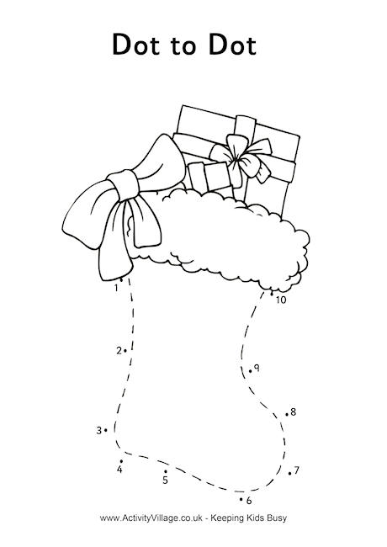

**Contact Information**

We need to ensure that we have your current contact numbers on our database, particularly mobile numbers. If you have recently changed your contact number, please inform the office.

[](http://www.google.co.uk/url?sa=i&rct=j&q=&esrc=s&source=images&cd=&cad=rja&uact=8&ved=0ahUKEwjK3Ibe3r7QAhUJLhoKHXz2DFEQjRwIBQ&url=http://www.moneysupermarket.com/mobile-phones/&psig=AFQjCNHeGSE_UQogfK4F8JxP7YEUyjGRIQ&ust=1479985761738409)

**Out of Hours Repairs**

**An emergency repairs service is available outside normal office hours.**

**To report a repair out of hours contact 0208 937 1234**

**Help with your Rent**

Paying your rent and any charges should be your top priority, and regardless of how you pay, you are responsible for ensuring that these are paid in full, and on time. Non-payment of rent, service charges or any other charge could lead to you losing your home.

T**enants are reminded that rent is payable weekly in advance, or monthly in advance**.

Housing staff will provide advice and guidance for tenants who have difficulty in paying rent. Whilst ‘Recovery of Possession’ (Eviction) of property is a last resort, Kilburn Square Housing Co-operative needs to protect its income and will take action against tenants who fail to pay their rent.

However, we recognise that there are many reasons why a tenant may have rent arrears.

If you have rent arrears and we have written to you, you must contact the Co-op office.

We will arrange a mutual appointment for you to see the Housing Officer or the Manager in confidence.

We will help you to get advice and support so that you can pay your rent.

And arrange a repayment plan to reduce and clear the arrears.

**Housing Benefit**

**If you are on a low income or unemployed you may be entitled to claim Housing Benefit Rebate.**

**We can help you to do this.**

**Please remember your home is at risk if you do not pay your rent**

**Major Works on the Kilburn Estate**

Major works have now started on the four low rise blocks Barrett, Rathbone, Sandby and Varley House, and scaffolding is been erected. The work will include new roofs, new double glazing windows, new balcony doors, masonry work, and some decorations.

The Resident Liaison for Wates is **Michael Bell contact number 0742 764 9894**.

Any problems or concerns you may have in regards to the works he can be contacted on the number between the hours of 9am-5.00pm. He is based in the blue porta-cabins in the compound on the estate.

**Out of hours contact**

**Daniel Filmer - Senior Site Manager Brent Planned Works  | Wates Living Space London**

**T: 0208 208 7760**| **M: 07753297688** |[Daniel.filmer@wates.co.uk](mailto:Daniel.filmer@wates.co.uk)

[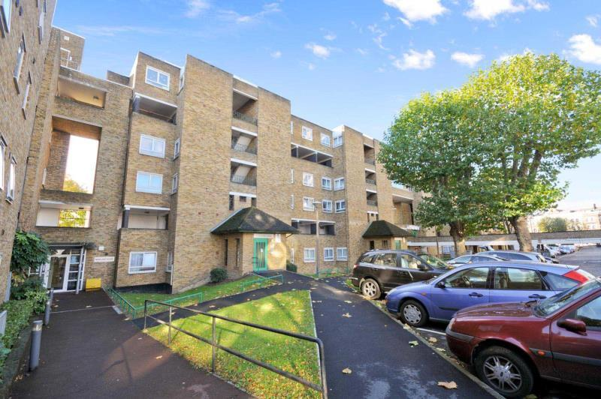](http://www.google.co.uk/url?sa=i&rct=j&q=&esrc=s&source=images&cd=&cad=rja&uact=8&ved=0ahUKEwi_z7eq_dLPAhXGmBoKHTZGB0wQjRwIBw&url=http://www.rightmove.co.uk/property-to-rent/property-48808907.html&psig=AFQjCNEeW1OyNa4M_LOTcih9AygfWebr8g&ust=1476283121573733)

**Behaviour of Children on the estate**

All parents must ensure that they take full responsibility for the behavior of their children and their friends. This includes when your child is playing on the estate. Parents and guardians must ensure that they know the whereabouts of their children and you should monitor your children when they are out to ensure they are safe.

Failing to ensure that members of household or visitors do not cause a nuisance is a breach of the terms and conditions of your agreement with Brent Council. Persistent anti- social behaviour may lead to agreements being terminated and the loss of your home.

[](http://www.google.co.uk/url?sa=i&rct=j&q=&esrc=s&source=images&cd=&ved=0ahUKEwjwhICV7tzQAhVM7hoKHaGKD1EQjRwIBw&url=http://www.quotationof.com/behaviour.html&psig=AFQjCNG9Ouh7TDwQlF9BKl2n-jp5Sv6JdA&ust=1481020691025098)

**Health and Safety**



Rodents on the rise!! We do not want to encourage rodents on our estate please do not leave rubbish outside your front doors or dump bulky items in the yard, this has led to a rise in rodents and we have had to increase and change the bait we use around the estate to ensure we are managing the increase. Help us to have a clean estate where were proud to live. Be aware for health and safety reasons rubbish or items must not be left outside your front doors.

**Housing Management Staff structure 2016**

Housing Services/Estate Manager Jennifer Williams

Housing Officer Linda Ponder

Finance Officer Yasmita Kotecha

Maintenance Officer Rudy Kelly

Front Desk/Security Co-ordinator Karis Pink

Caretakers William Borrill

Kathy Proudfoot Jones Ivory

[](http://www.google.co.uk/url?sa=i&rct=j&q=&esrc=s&source=images&cd=&cad=rja&uact=8&ved=0ahUKEwi56NC6veLQAhUFMBoKHQhwDDUQjRwIBw&url=http://www.dltk-holidays.com/xmas/m-wordsearch.htm&psig=AFQjCNHFl5h7SmeS46T6iXTRn9mOj_3JYQ&ust=1481213777640519)

|  |
| --- |
| **MEETINGS AND EVENTS FOR 2017…………..** |

**All Residents and Leaseholders are encouraged to attend future Board Meetings to have your say on how the TMO provide services to the estate.**



|  |  |  |  |  |  |
| --- | --- | --- | --- | --- | --- |
| **Board Meetings are held every 1st Tuesday of the Month**   |  | | --- | | **10th January 2017**  **14th February 2017**  **14th March 2017**  **11th April 2017**  **16th May 2017**  **13th June 2017**  **11th July 2017**  **15th August 2017**  **12th September 2017** |   **General & AGM meetings Thursdays**  **8th December 2016 - General Meeting & Christmas Party**  **16th March 2017- General Meeting**  **15th June 2017- General Meeting**  **14th September 2017 AGM** | | | | |
|  | | | | |
|  |  |  |  |  |

[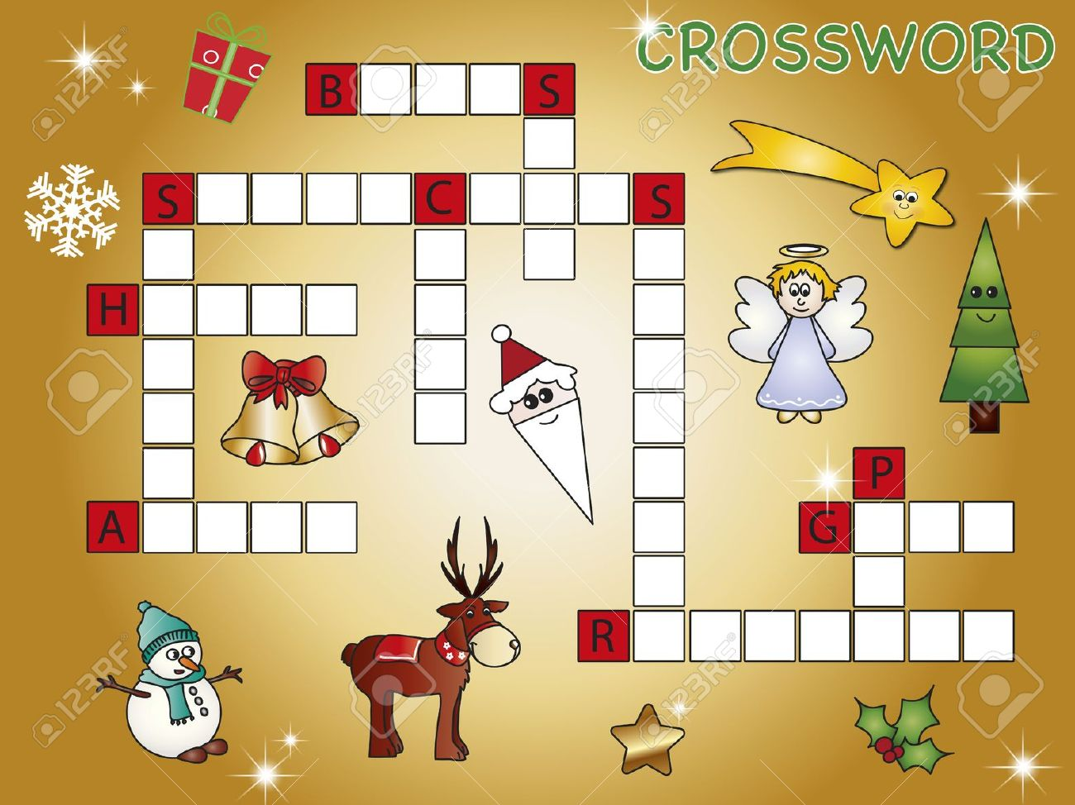](http://www.123rf.com/photo_15695209_crossword-christmas.html)