|  |
| --- |
| KILBURN SQUARE NEWSLETTER |
| **January 2017**  **Useful information of what’s happening on your estate including events.** |
| G |
|  |





Welcome to Kilburn Square newsletter for January 2017.

Kilburn Square currently has 8 Committee Members; please see below the names of our current Committee Members.

|  |  |
| --- | --- |
| **TITLE** | **NAME** |
| Chair | Margaret Stoll |
| Deputy Chair | Vacant |
| Secretary | Jennifer Welch |
| Treasurer | Mahmood Hassan |
| Committee Member | Pauline Fell |
| Committee Member | Zaler Montana |
| Committee Member | Martin Page |
| Committee Member | Antonio Messina |
| Committee Member | Patricia Hogan |
|  |  |
|  |

**Kilburn Square Tower Block**

Please note we have received a number of complaints about food and glass jars been thrown out of the windows in the Tower block. Please note this is a breach of your Tenancy Agreement/Lease and a serious health and safety issue. If the perpetrator is caught, it could result in you losing your tenancy or lease being revoked by the Council.

[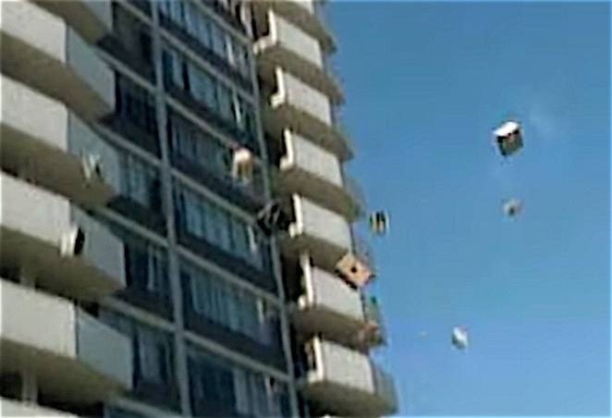](http://www.treehugger.com/environmental-policy/tvs-ending-dumps-because-they-are-too-expensive-recycle.html)

**Modular Management Agreement (MMA)**

It has been in discussion for some time that our current management agreement dated 1994 needs to be reviewed. There are lots of changes within Brent Council and cuts to revenue and part of these changes means Kilburn Square Housing Co-operative has to focus on renewing the management agreement. The MMA has now been reviewed and returned to Brent Council, an update of the MMA will be given to all residents when Brent have returned the document back to us.

This may also mean KSHC having to consider doing some fundraising in order to balance the books and to fund events held at Kilburn Square.

**Tenancy Audit**

We will be carrying out tenancy audits over the next few months, there is no need to wait in for us. We will leave a card if you are not in when we call, for you to contact us to arrange a new appointment for us to re visit.

**Residents should provide one type of identification from LIST A and one type of identification from LIST B below for each member of their household:**

**List A**

**(Proof of identity)**

Full UK or EU driving licence (with photograph)

Ten year UK or EU passport (with photograph)

Home Office documents confirming status

A current, valid credit or debit card with supporting bank statements

Pension book showing name and address

For elderly residents, the travel pass for free public transport (with photograph)

If none of the above is available, the following documents may be considered, but do not prove conclusive proof of identity:

Student identity card

Public sector work ID card

National Insurance number card

Medical card with national insurance number

Birth/ adoption/ marriage certificate

P46/P60

Certificate of employment in the HM forces

**List B**

**Showing current address (proof of residency)**

Household/ utility bill

TV licence

Car registration documents

Drivers licence (without photograph)

Correspondence from government departments (such as DWP, NHS or Borders and immigration)

So, for instance, they could provide a Passport from LIST A and Council Tax Bill from LIST B for each member of their household as identification. Please also note that some documents are deemed illegal if they are not updated to show a person’s current address.

**Security on the estate**

[](http://www.google.co.uk/url?sa=i&rct=j&q=&esrc=s&source=images&cd=&cad=rja&uact=8&ved=0ahUKEwiBj8vdutrRAhWCPhQKHR2RDHgQjRwIBw&url=http://www.mydoorsign.com/Door-Signs/Open-Closed-Door-Sign.aspx&bvm=bv.144686652,d.d24&psig=AFQjCNGLZ0NnTLGaKa-DPgRkbqSXOHDnXw&ust=1485336187305202)

Residents are reminded that they need to close the doors behind them when exiting their block.

**Resident Participation**

Come out in your numbers on a Friday in the committee room where there is fun and laughter and BINGO. It’s a way of meeting others on the estate and having fun. All are welcome.

**Co-op Membership**



All leaseholders and tenants are welcome to join Kilburn Square Housing Co-operative membership. Membership is £1.00 each. If you are a Co-op member you can attend General Meetings and Annual General Meetings and you can voice your opinions on matters. Have your say on the running of the estate and receive a discount price for events by Kilburn Square. Please note leaseholders sub-tenants cannot become a member.

**Carpark Gates**

Residents are reminded that they need to use their fobs when vacating the estate in a vehicle. Tailgating is the act of driving too close to the vehicle in front, such that the distance between the two vehicles does not guarantee that the gates will remain open.

“**Shattif” Bidet shower Spray**

Residents are reminded that they are not allowed to install bidet shower sprays in toilets within their flats.

**Contact Information**

We need to ensure that we have your current contact numbers on our database, particularly mobile numbers. If you have recently changed your contact number, please inform the office. We also need to be informed of your next of kin in case of emergencies.

[](http://www.google.co.uk/url?sa=i&rct=j&q=&esrc=s&source=images&cd=&cad=rja&uact=8&ved=0ahUKEwjK3Ibe3r7QAhUJLhoKHXz2DFEQjRwIBQ&url=http://www.moneysupermarket.com/mobile-phones/&psig=AFQjCNHeGSE_UQogfK4F8JxP7YEUyjGRIQ&ust=1479985761738409)

**Out of Hours Repairs**

**An emergency repairs service is available outside normal office hours.**

**To report a repair out of hours contact 0208 937 1234**

**Help with your Rent**

Paying your rent and any charges should be your top priority, and regardless of how you pay, you are responsible for ensuring that these are paid in full, and on time. Non-payment of rent, service charges or any other charge could lead to you losing your home.

T**enants are reminded that rent is payable weekly in advance, or monthly in advance**.

Housing staff will provide advice and guidance for tenants who have difficulty in paying rent. Whilst ‘Recovery of Possession’ (Eviction) of property is a last resort, Kilburn Square Housing Co-operative needs to protect its income and will take action against tenants who fail to pay their rent.

However, we recognise that there are many reasons why a tenant may have rent arrears.

If you have rent arrears and we have written to you, you must contact the Co-op office.

We will arrange a mutual appointment for you to see the Housing Officer or the Manager in confidence.

We will help you to get advice and support so that you can pay your rent.

And arrange a repayment plan to reduce and clear the arrears.

**Housing Benefit**

**If you are on a low income or unemployed you may be entitled to claim Housing Benefit Rebate.**

**We can help you to do this.**

**Please remember your home is at risk if you do not pay your rent**

**Parcels**

**All residents please note Kilburn Square office is not insured to accept parcels on behalf of residents.**

[](http://www.google.co.uk/url?sa=i&rct=j&q=&esrc=s&source=images&cd=&cad=rja&uact=8&ved=0ahUKEwiI-aPq3NjRAhVE2hoKHXQUCcsQjRwIBQ&url=http://www.rpdistribution.co.uk/parcel-delivery.asp&psig=AFQjCNERXDkdWSjRj-seS3Gt34dAzenQRw&ust=1485276650221696)

**Cleaning Front Doors**

Please note tenants are responsible for cleaning their own individual front doors.

[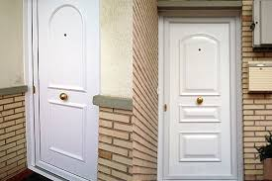](https://www.google.co.uk/imgres?imgurl=http://farm8.static.flickr.com/7101/7315238272_a9df469f29.jpg&imgrefurl=http://www.arquigrafico.net/choosing-a-front-door-upvc-or-wood/&docid=3gnL-n6CPilUWM&tbnid=F5uPrbUSfBFQNM:&vet=1&w=500&h=333&hl=en&bih=900&biw=1280&q=Pictures%20of%20dirty%20%20front%20doors&ved=0ahUKEwjDuMPb3djRAhXK6xoKHWNSD6IQMwiEAShhMGE&iact=mrc&uact=8)

**Smoke Alarms**

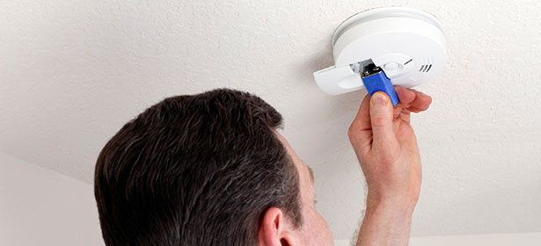

What maintenance do my smoke detectors need?

Smoke alarms need very little maintenance, but follow these simple steps to keep yours in good working order. Use the test button to test the smoke alarm's battery weekly. Change the battery each year (unless it's a 10-year alarm). Gently vacuum inside the case (using the soft brush attachment) to remove dust from the smoke alarm sensors. If the case doesn't open, vacuum through the holes. Get a new smoke alarm after 10 years.

**Major Works on the Kilburn Estate**

The Resident Liaison for Wates is **Michael Bell contact number 0742 764 9894**.

Any problems or concerns you may have in regards to the works he can be contacted on the number between the hours of 9am-5.00pm. He is based in the blue porta-cabins in the compound on the estate.

**Out of hours contact**

**Daniel Filmer - Senior Site Manager Brent Planned Works  | Wates Living Space London**

**T: 0208 208 7760**| **M: 07753297688** |[Daniel.filmer@wates.co.uk](mailto:Daniel.filmer@wates.co.uk)

**Behaviour of Children on the estate**

All parents must ensure that they take full responsibility for the behavior of their children and their friends. This includes when your child is playing on the estate. Parents and guardians must ensure that they know the whereabouts of their children and you should monitor your children when they are out to ensure they are safe.

Failing to ensure that members of household or visitors do not cause a nuisance is a breach of the terms and conditions of your agreement with Brent Council. Persistent anti- social behaviour may lead to agreements being terminated and the loss of your home.

**Health and Safety**

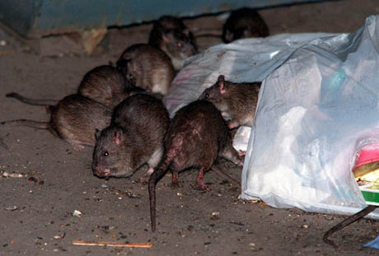

Rodents on the rise!! We do not want to encourage rodents on our estate please do not leave rubbish outside your front doors or dump bulky items in the yard, this has led to a rise in rodents and we have had to increase and change the bait we use around the estate to ensure we are managing the increase. Help us to have a clean estate where were proud to live. Be aware for health and safety reasons rubbish or items must not be left outside your front doors.

**Housing Management Staff structure 2017**

Housing Services/Estate Manager Jennifer Williams

Housing Officer Linda Ponder

Finance Officer Yasmita Kotecha

Maintenance Officer Rudy Kelly

Front Desk/Security Co-ordinator Karis Pink

Caretakers William Borrill

Kathy Proudfoot Jones Ivory

|  |
| --- |
| **MEETINGS AND EVENTS FOR 2017…………..** |

**All Residents and Leaseholders are encouraged to attend future Board Meetings to have your say on how the TMO provide services to the estate.**



|  |  |  |  |  |  |  |  |  |  |  |  |  |  |  |  |  |  |  |  |  |  |  |
| --- | --- | --- | --- | --- | --- | --- | --- | --- | --- | --- | --- | --- | --- | --- | --- | --- | --- | --- | --- | --- | --- | --- |
| **Board Meetings are held every 1st Tuesday of the Month**   |  | | --- | | **14th February 2017**  **14th March 2017**  **11th April 2017**  **16th May 2017**  **13th June 2017**  **11th July 2017**  **15th August 2017**  **12th September 2017** |   **General & AGM meetings Thursdays**  **16th March 2017- General Meeting**  **15th June 2017- General Meeting**  **14th September 2017 AGM** | | | | | | | | | | | | | | | | | | | | | |
|  | | | | | | | | | | | | | | | | | | | | | |
| **WINTER WORD SEARCH** | | | | | | | | | | | | | | | | | |  |  |  |  |
| I | D | W | Y | Y | J | F | F | S | C | G | F | P | H | E | E | I | S |
| S | W | E | A | T | E | R | N | I | F | L | R | J | E | S | N | O | W |
| T | N | R | G | Y | O | O | T | I | Y | O | O | L | K | P | F | E | N |
| S | T | T | R | L | W | C | R | X | X | V | S | X | A | B | R | Z | B |
| O | C | D | Y | B | R | E | W | H | D | E | T | T | L | J | E | Y | E |
| S | A | A | O | A | P | M | I | G | C | S | P | W | F | E | E | K | W |
| X | E | A | R | Q | Q | B | C | O | A | T | S | D | W | H | Z | Z | N |
| I | R | A | N | F | E | S | N | O | W | M | A | N | O | E | E | P | I |
| D | C | M | S | R | D | R | A | Z | Z | I | L | B | N | A | I | Q | N |
| Z | P | I | N | O | D | L | O | C | G | Q | U | B | S | T | S | C | R |
| M | E | A | C | J | N | Q | C | C | L | C | W | L | K | E | F | K | E |
| S | T | Q | Z | L | M | K | I | V | G | H | Q | P | I | R | B | H | I |
| E | R | C | D | L | E | O | N | R | I | L | U | R | I | U | W | L | L |

|  |  |  |
| --- | --- | --- |
| ARCTIC | BLIZZARD | COAT |
| COLD | FIRE | FREEZE |
| FROST | GLOVES | HEATER |
| HIBERNATE | ICE | ICICLE |
| SCARF | SEASON | SKI |
| SNOW | SNOWBOARD | SNOWFLAKE |
| SNOWMAN | SWEATER |  |