|  |
| --- |
| KILBURN SQUARE NEWSLETTER |
| **May 2017**  **Useful information of what’s happening on your estate including events.** |
| G |
|  |



[](http://www.google.co.uk/url?sa=i&rct=j&q=&esrc=s&source=images&cd=&cad=rja&uact=8&ved=0ahUKEwiLhp256r_TAhUBLMAKHSbiCg4QjRwIBw&url=http://oklahomafood.coop/news/&psig=AFQjCNHDQAIBfTEH7g0KM4kSpiUt2QtkfA&ust=1493217260326377)

Welcome to Kilburn Square newsletter for May 2017.

Kilburn Square currently has 7 Committee Members; please see below the names of our current Committee Members.

|  |  |
| --- | --- |
| **TITLE** | **NAME** |
| Chair | Margaret Stoll |
| Deputy Chair | Vacant |
| Secretary | Jennifer Welch |
| Treasurer | Antonio Messina |
| Committee Member | Pauline Fell |
| Committee Member | Zaler Montana |
| Committee Member | Martin Page |
| Committee Member | Vacant |
| Committee Member | Patricia Hogan |
|  |  |
|  |

**Kilburn Square Tower Block**

Please note we have received a number of complaints about food and glass jars been thrown out of the windows in the Tower block. Please note this is a breach of your Tenancy Agreement/Lease and a serious health and safety issue. If the perpetrator is caught, it could result in you losing your tenancy or lease being revoked by the Council.

[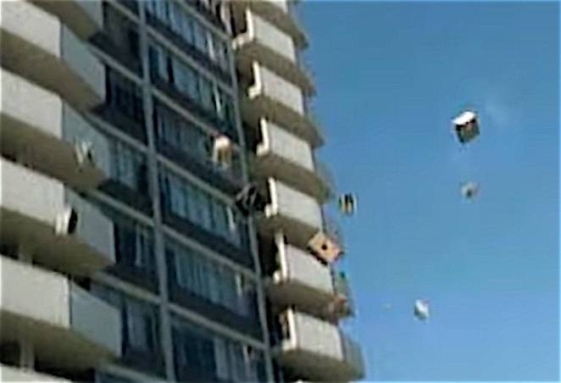](http://www.treehugger.com/environmental-policy/tvs-ending-dumps-because-they-are-too-expensive-recycle.html)

**Tenancy Audits**

KSHC on behalf of Brent Council are carrying out a tenancy audit on all tenanted

rented council properties. This is a reminder that a number of tenants that have still not made contact with the office in order for their audit to be carried out.

Please contact Linda Ponder to arrange a suitable date and time at your convenience Monday-Friday between 9am-5.00pm.

**Tenants Responsibilities**

As part of your [**Tenancy Agreemen**](http://www.lewishamhomes.org.uk/your-home/tenancy/your-tenancy-agreement/)**t** you have a number of responsibilities you must follow.

Your Tenancy Agreement sets out some rules that you, and those who live in or visit your home, must follow by law. Your full tenancy conditions and your rights and responsibilities are listed in your Tenancy Agreement, but here is a summary of the key points:

* Pay all charges for gas, electricity, and telephone services direct to your providers.
* Not to run a business from your home without our permission in writing or use your property for any criminal, illegal or immoral purposes;
* Not to cause a nuisance, annoyance or excessive noise, or allow your visitors to do so;
* Not to harass, threaten or use violence or intimidate people;
* Report promptly any [**repair**](http://www.lewishamhomes.org.uk/your-home/repairs/)or defect to KSHC;
* Allow workmen, employees or agents [**access at all reasonable hours**](http://www.lewishamhomes.org.uk/your-home/repairs/access-to-your-home-to-carry-out-repairs/) to inspect the condition of the premises or to carry out repairs or other works to the premises or adjoining property. (KSHC will usually give at least 24 hours - notice but immediate access may be required in an emergency);
* Not to cause any damage to the premises or the fixtures and fittings belonging to Brent Council;
* Not to keep on the premises any mobile gas heaters, cylinders, oil burning appliances, paraffin or petrol;
* Keep all communal areas clean, tidy and free from obstructions and rubbish which might cause injury nuisance and annoyance to others;
* You must seek permission from KSHC to keep pets at your property, and ensure they do not cause a nuisance or foul in public or communal areas;
* Use the bin chutes and recycling bins properly.

**Gas Safety Checks**

Landlords are legally obliged (in accordance with Gas Safety Regulations 1998) to obtain a gas safety certificate (CP12) every twelve months. Therefore it is imperative that tenants co-operate with the Council in order for the (CP12) to be completed.

The contractor will be entitled to charge the Council for visits following evidence that they have arranged and made 3 unsuccessful visits. These charges will be recharged to the tenant.

**Forced Entry**

As a final mechanism to ensure the Council compliance with its statutory obligations, it will force entry to carry out a service. Every effort will be made to avoid this, through written correspondence and other appropriate methods of communication.

Please note if the Council have to apply to the courts for a warrant for forced entries. The tenant will be recharged **£300.14 minimum,** this could increase dependent on what locks are changed. The amount will be added to your rent account for recovery.

**Security on the estate**

[](http://www.google.co.uk/url?sa=i&rct=j&q=&esrc=s&source=images&cd=&cad=rja&uact=8&ved=0ahUKEwiBj8vdutrRAhWCPhQKHR2RDHgQjRwIBw&url=http://www.mydoorsign.com/Door-Signs/Open-Closed-Door-Sign.aspx&bvm=bv.144686652,d.d24&psig=AFQjCNGLZ0NnTLGaKa-DPgRkbqSXOHDnXw&ust=1485336187305202)

Residents are reminded that they need to close the doors behind them when exiting their block.

**Resident Participation**

Come out in your numbers on a Friday in the committee room where there is fun and laughter and BINGO. It’s a way of meeting others on the estate and having fun. All are welcome.

**Co-op Membership**



All leaseholders and tenants are welcome to join Kilburn Square Housing Co-operative membership. Membership is £1.00 each. If you are a Co-op member you can attend General Meetings and Annual General Meetings and you can voice your opinions on matters. Have your say on the running of the estate and receive a discount price for events by Kilburn Square. Please note leaseholders sub-tenants cannot become a member.

**Keeping Pests Out Of Your Home**

[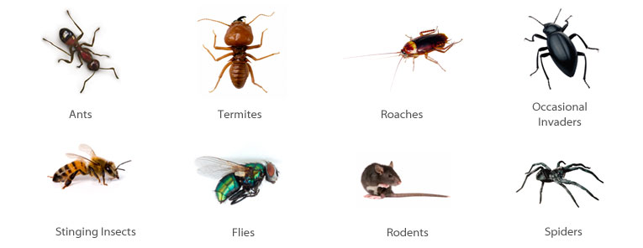](http://www.google.co.uk/url?sa=i&rct=j&q=&esrc=s&source=images&cd=&cad=rja&uact=8&ved=0ahUKEwiR0NH34r_TAhVLDMAKHR1OB2YQjRwIBw&url=http://www.cooks-termite.net/termiteandpestcontrol.nxg&psig=AFQjCNHQyHISYLnto5nOLgzQBbX2ewql-Q&ust=1493215368772747)

We’re not talking about your noisy neighbour or your annoying uncle Fred. These are tips to keep those pesky pests and insects out of your home. You know all the pests you love to hate like roaches, ants, spiders, crickets, and mice.

**Here are 10 great tips to help prevent pests from ever entering your home:**

* Keep the floors clean: wipe up any spills immediately using soap and water not just a rag. Clean the entire flooring at least once a week and the kitchen floor at least twice a week.
* Take out the rubbish: every day, do not leave trash in your home overnight. This includes all trash cans not just in the kitchen.
* Keep fruit in the refrigerator: especially when ripe.
* Keep the sink clean: wash dishes daily. If you cannot clean the dishes, then at least fill the sink with soap and water.
* Keep a tight lid on things: make sure all food and beverage containers kept outside of the refrigerator are tightly sealed. Keep bags of cereal, seeds and grains in a sealed container**.**
* Keep things dry: make sure the bathrooms, kitchens and laundry rooms are dry. Ensure leaks are fixed immediately and wipe up any spills or splashes at once.
* Keep pets clean: brushing, bathing and using flea and tick protection on your animals, especially indoor/outdoor pets.
* Seal up the house: ensure there are no cracks on baseboards, pipes, ducts, and fittings inside the home. Check outside door frames, window frames, roof joints and any visible cracks on the exterior surface.

**Contact Information**

We need to ensure that we have your current contact numbers on our database, particularly mobile numbers. If you have recently changed your contact number, please inform the office. We also need to be informed of your next of kin in case of emergencies.

[](http://www.google.co.uk/url?sa=i&rct=j&q=&esrc=s&source=images&cd=&cad=rja&uact=8&ved=0ahUKEwjK3Ibe3r7QAhUJLhoKHXz2DFEQjRwIBQ&url=http://www.moneysupermarket.com/mobile-phones/&psig=AFQjCNHeGSE_UQogfK4F8JxP7YEUyjGRIQ&ust=1479985761738409)

**Out of Hours Repairs**

**An emergency repairs service is available outside normal office hours.**

**To report a repair out of hours contact 0208 937 1234**

**Help with your Rent**

Paying your rent and any charges should be your top priority, and regardless of how you pay, you are responsible for ensuring that these are paid in full, and on time. Non-payment of rent, service charges or any other charge could lead to you losing your home.

T**enants are reminded that rent is payable weekly in advance, or monthly in advance**.

Housing staff will provide advice and guidance for tenants who have difficulty in paying rent. Whilst ‘Recovery of Possession’ (Eviction) of property is a last resort, Kilburn Square Housing Co-operative needs to protect its income and will take action against tenants who fail to pay their rent.

However, we recognise that there are many reasons why a tenant may have rent arrears.

If you have rent arrears and we have written to you, you must contact the Co-op office.

We will arrange a mutual appointment for you to see the Housing Officer or the Manager in confidence.

We will help you to get advice and support so that you can pay your rent.

And arrange a repayment plan to reduce and clear the arrears.

**Housing Benefit**

**If you are on a low income or unemployed you may be entitled to claim Housing Benefit Rebate.**

**We can help you to do this.**

**Please remember your home is at risk if you do not pay your rent**

**Parcels**

**All residents please note Kilburn Square office is not insured to accept parcels on behalf of residents.**

[](http://www.google.co.uk/url?sa=i&rct=j&q=&esrc=s&source=images&cd=&cad=rja&uact=8&ved=0ahUKEwiI-aPq3NjRAhVE2hoKHXQUCcsQjRwIBQ&url=http://www.rpdistribution.co.uk/parcel-delivery.asp&psig=AFQjCNERXDkdWSjRj-seS3Gt34dAzenQRw&ust=1485276650221696)

**Behaviour of Children on the estate**

All parents must ensure that they take full responsibility for the behavior of their children and their friends. This includes when your child is playing on the estate. Parents and guardians must ensure that they know the whereabouts of their children and you should monitor your children when they are out to ensure they are safe.

Failing to ensure that members of household or visitors do not cause a nuisance is a breach of the terms and conditions of your agreement with Brent Council. Persistent anti- social behaviour may lead to agreements being terminated and the loss of your home.

**Health and Safety**

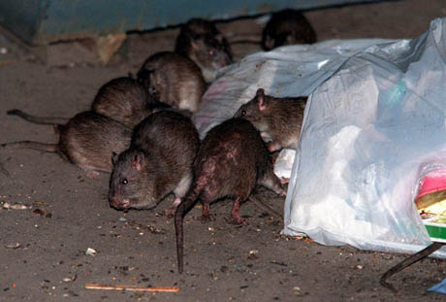

Rodents on the rise!! We do not want to encourage rodents on our estate please do not leave rubbish outside your front doors or dump bulky items in the yard, this has led to a rise in rodents and we have had to increase and change the bait we use around the estate to ensure we are managing the increase. Help us to have a clean estate where were proud to live. Be aware for health and safety reasons rubbish or items must not be left outside your front doors.

**Housing Management Staff structure 2017**

Housing Services/Estate Manager Jennifer Williams

Housing Officer Linda Ponder

Finance Officer Yasmita Kotecha

Maintenance Officer Rudy Kelly

Front Desk/Security Co-ordinator Karis Pink

Caretakers William Borrill

Kathy Proudfoot Jones Ivory

|  |
| --- |
| **MEETINGS AND EVENTS FOR 2017…………..** |

**All Residents and Leaseholders are encouraged to attend future Board Meetings to have your say on how the TMO provide services to the estate.**

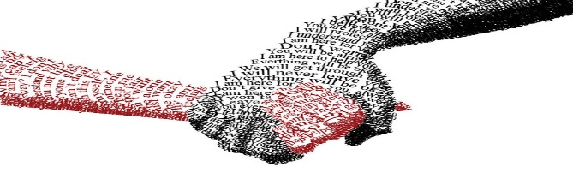

|  |  |  |  |  |  |  |  |  |  |  |  |  |  |  |  |  |  |  |  |  |  |  |  |  |  |  |  |  |  |  |  |  |  |  |  |  |  |  |  |  |  |  |  |  |  |  |  |  |  |  |  |  |  |  |  |  |  |  |  |  |  |  |  |  |  |  |  |  |  |  |  |  |  |  |  |  |  |  |  |  |  |  |  |  |  |  |  |  |  |  |  |  |  |  |  |  |  |  |  |  |  |  |  |  |  |  |  |  |  |  |  |  |  |  |  |  |  |  |  |  |  |  |  |  |  |  |  |  |  |  |  |  |  |  |  |  |  |  |  |  |  |  |  |  |  |  |  |  |  |  |  |  |  |  |  |  |  |  |  |  |  |  |  |  |  |  |  |  |  |  |  |  |  |  |  |  |  |  |  |  |  |  |  |  |  |  |  |  |  |  |  |  |  |  |  |  |  |  |  |  |  |  |  |  |  |  |  |  |  |  |  |  |  |  |  |  |  |  |  |  |  |  |  |  |  |  |  |  |  |  |  |  |  |  |  |  |  |  |  |  |  |  |  |  |  |  |  |  |  |  |  |  |  |  |  |  |  |  |  |  |  |  |  |  |  |  |  |  |  |  |  |  |  |  |  |  |  |  |  |  |  |  |  |  |  |  |  |  |  |  |  |  |  |  |  |  |  |  |  |  |  |  |  |  |  |  |  |  |  |  |  |  |  |  |  |  |  |  |  |  |  |  |  |  |  |  |  |  |  |  |  |  |  |  |  |  |  |  |  |  |  |  |  |  |  |  |  |  |  |  |  |  |  |  |  |  |  |  |  |  |  |  |  |  |  |  |  |  |  |  |  |  |  |  |  |  |  |  |  |  |  |  |  |  |  |  |  |  |  |  |  |  |  |  |  |  |  |  |  |  |  |  |  |  |  |  |  |  |  |  |  |  |  |  |  |  |  |  |  |  |  |  |  |  |
| --- | --- | --- | --- | --- | --- | --- | --- | --- | --- | --- | --- | --- | --- | --- | --- | --- | --- | --- | --- | --- | --- | --- | --- | --- | --- | --- | --- | --- | --- | --- | --- | --- | --- | --- | --- | --- | --- | --- | --- | --- | --- | --- | --- | --- | --- | --- | --- | --- | --- | --- | --- | --- | --- | --- | --- | --- | --- | --- | --- | --- | --- | --- | --- | --- | --- | --- | --- | --- | --- | --- | --- | --- | --- | --- | --- | --- | --- | --- | --- | --- | --- | --- | --- | --- | --- | --- | --- | --- | --- | --- | --- | --- | --- | --- | --- | --- | --- | --- | --- | --- | --- | --- | --- | --- | --- | --- | --- | --- | --- | --- | --- | --- | --- | --- | --- | --- | --- | --- | --- | --- | --- | --- | --- | --- | --- | --- | --- | --- | --- | --- | --- | --- | --- | --- | --- | --- | --- | --- | --- | --- | --- | --- | --- | --- | --- | --- | --- | --- | --- | --- | --- | --- | --- | --- | --- | --- | --- | --- | --- | --- | --- | --- | --- | --- | --- | --- | --- | --- | --- | --- | --- | --- | --- | --- | --- | --- | --- | --- | --- | --- | --- | --- | --- | --- | --- | --- | --- | --- | --- | --- | --- | --- | --- | --- | --- | --- | --- | --- | --- | --- | --- | --- | --- | --- | --- | --- | --- | --- | --- | --- | --- | --- | --- | --- | --- | --- | --- | --- | --- | --- | --- | --- | --- | --- | --- | --- | --- | --- | --- | --- | --- | --- | --- | --- | --- | --- | --- | --- | --- | --- | --- | --- | --- | --- | --- | --- | --- | --- | --- | --- | --- | --- | --- | --- | --- | --- | --- | --- | --- | --- | --- | --- | --- | --- | --- | --- | --- | --- | --- | --- | --- | --- | --- | --- | --- | --- | --- | --- | --- | --- | --- | --- | --- | --- | --- | --- | --- | --- | --- | --- | --- | --- | --- | --- | --- | --- | --- | --- | --- | --- | --- | --- | --- | --- | --- | --- | --- | --- | --- | --- | --- | --- | --- | --- | --- | --- | --- | --- | --- | --- | --- | --- | --- | --- | --- | --- | --- | --- | --- | --- | --- | --- | --- | --- | --- | --- | --- | --- | --- | --- | --- | --- | --- | --- | --- | --- | --- | --- | --- | --- | --- | --- | --- | --- | --- | --- | --- | --- | --- | --- | --- | --- | --- | --- | --- | --- | --- | --- | --- | --- | --- | --- | --- | --- | --- | --- | --- | --- | --- | --- | --- | --- | --- | --- | --- | --- | --- | --- | --- | --- | --- | --- | --- | --- | --- | --- | --- | --- | --- | --- | --- | --- | --- | --- | --- | --- | --- | --- | --- | --- | --- | --- | --- | --- | --- | --- | --- | --- | --- | --- | --- | --- | --- | --- |
| **Board Meetings are held every 1st Tuesday of the Month**   |  | | --- | | **16th May 2017**  **13th June 2017**  **11th July 2017**  **15th August 2017**  **12th September 2017** |   **General & AGM meetings Thursdays**  **15th June 2017- General Meeting**  **14th September 2017 AGM**  **May Day - Word Search Puzzle**  Can you find the hidden words connected with May Day customs and traditions in this word search puzzle?  All the words go across or down.   |  |  |  |  |  |  |  |  |  |  |  |  |  |  |  |  |  |  |  |  |  |  |  |  |  |  |  |  |  |  |  |  |  |  |  |  |  |  |  |  |  |  |  |  |  |  |  |  |  |  |  |  |  |  |  |  |  |  |  |  |  |  |  |  |  |  |  |  |  |  |  |  |  |  |  |  |  |  |  |  |  |  |  |  |  |  |  |  |  |  |  |  |  |  |  |  |  |  |  |  |  |  |  |  |  |  |  |  |  |  |  |  |  |  |  |  |  |  |  |  |  |  |  |  |  |  |  |  |  |  |  |  |  |  |  |  |  |  |  |  |  |  |  |  |  |  |  |  |  |  |  |  |  |  |  |  |  |  |  |  |  |  |  |  |  |  |  |  |  |  |  |  |  |  |  |  |  |  |  |  |  |  |  |  |  |  |  |  |  |  |  |  |  |  |  |  |  |  |  |  |  |  |  |  |  |  |  |  |  |  |  |  |  |  |  |  |  |  |  |  |  |  |  |  |  |  |  |  |  |  |  |  |  |  |  |  |  |  |  |  |  |  |  |  |  |  |  |  |  |  |  |  |  |  |  |  |  |  |  |  |  |  |  |  |  |  |  |  |  |  |  |  |  |  |  |  |  |  |  |  |  |  |  |  |  |  |  |  |  |  |  |  |  |  |  |  |  |  |  |  |  |  |  |  |  |  |  |  |  |  |  |  |  |  |  |  |  |  |  |  |  |  |  |  |  |  |  |  |  |  |  |  |  |  |  |  |  |  |  |  |  |  |  |  |  |  |  |  |  |  |  |  |  |  |  |  |  |  |  |  |  |  |  |  |  |  |  |  |  |  |  |  |  |  |  |  |  |  |  |  |  |  |  |  |  |  |  |  |  |  |  |  |  |  |  |  |  |  |  |  |  |  |  |  |  |  |  |  |  |  |  |  |  |  |  |  |  |  |  |  |  |  |  | | --- | --- | --- | --- | --- | --- | --- | --- | --- | --- | --- | --- | --- | --- | --- | --- | --- | --- | --- | --- | --- | --- | --- | --- | --- | --- | --- | --- | --- | --- | --- | --- | --- | --- | --- | --- | --- | --- | --- | --- | --- | --- | --- | --- | --- | --- | --- | --- | --- | --- | --- | --- | --- | --- | --- | --- | --- | --- | --- | --- | --- | --- | --- | --- | --- | --- | --- | --- | --- | --- | --- | --- | --- | --- | --- | --- | --- | --- | --- | --- | --- | --- | --- | --- | --- | --- | --- | --- | --- | --- | --- | --- | --- | --- | --- | --- | --- | --- | --- | --- | --- | --- | --- | --- | --- | --- | --- | --- | --- | --- | --- | --- | --- | --- | --- | --- | --- | --- | --- | --- | --- | --- | --- | --- | --- | --- | --- | --- | --- | --- | --- | --- | --- | --- | --- | --- | --- | --- | --- | --- | --- | --- | --- | --- | --- | --- | --- | --- | --- | --- | --- | --- | --- | --- | --- | --- | --- | --- | --- | --- | --- | --- | --- | --- | --- | --- | --- | --- | --- | --- | --- | --- | --- | --- | --- | --- | --- | --- | --- | --- | --- | --- | --- | --- | --- | --- | --- | --- | --- | --- | --- | --- | --- | --- | --- | --- | --- | --- | --- | --- | --- | --- | --- | --- | --- | --- | --- | --- | --- | --- | --- | --- | --- | --- | --- | --- | --- | --- | --- | --- | --- | --- | --- | --- | --- | --- | --- | --- | --- | --- | --- | --- | --- | --- | --- | --- | --- | --- | --- | --- | --- | --- | --- | --- | --- | --- | --- | --- | --- | --- | --- | --- | --- | --- | --- | --- | --- | --- | --- | --- | --- | --- | --- | --- | --- | --- | --- | --- | --- | --- | --- | --- | --- | --- | --- | --- | --- | --- | --- | --- | --- | --- | --- | --- | --- | --- | --- | --- | --- | --- | --- | --- | --- | --- | --- | --- | --- | --- | --- | --- | --- | --- | --- | --- | --- | --- | --- | --- | --- | --- | --- | --- | --- | --- | --- | --- | --- | --- | --- | --- | --- | --- | --- | --- | --- | --- | --- | --- | --- | --- | --- | --- | --- | --- | --- | --- | --- | --- | --- | --- | --- | --- | --- | --- | --- | --- | --- | --- | --- | --- | --- | --- | --- | --- | --- | --- | --- | --- | --- | --- | --- | --- | --- | --- | --- | --- | --- | --- | --- | --- | --- | --- | --- | --- | --- | --- | --- | --- | --- | --- | --- | --- | --- | --- | --- | --- | --- | --- | --- | --- | --- | --- | --- | --- | --- | --- | --- | --- | --- | --- | --- | --- | --- | --- | --- | --- | --- | --- | --- | --- | --- | --- | --- | --- | --- | --- | --- | --- | --- | --- | --- | --- | --- | | |  |  |  |  |  |  |  |  |  |  |  |  |  |  |  |  |  |  |  |  |  | | --- | --- | --- | --- | --- | --- | --- | --- | --- | --- | --- | --- | --- | --- | --- | --- | --- | --- | --- | --- | --- | | Z | F | V | F | D | C | L | Y | F | V | I | L | L | A | G | E | C | U | P | S |  | | W | V | I | C | K | E | M | U | V | Q | M | T | O | Z | L | D | E | N | E | P |  | | T | Z | Y | A | C | L | M | E | Y | U | T | W | G | I | N | H | A | Z | E | R |  | | D | P | R | O | C | E | S | S | I | O | N | M | I | O | K | F | Y | F | D | I |  | | A | F | G | I | T | B | K | Q | J | G | A | X | P | N | N | E | M | J | F | N |  | | N | A | A | Z | S | R | B | T | W | M | I | J | G | G | Y | S | R | O | F | G |  | | C | I | P | I | B | A | E | W | Y | O | O | K | M | F | K | T | P | T | R | E |  | | E | R | V | D | R | T | L | Y | U | R | T | V | X | M | M | I | J | R | A | G |  | | P | S | M | M | C | I | T | O | D | R | P | M | E | F | A | V | P | A | B | O |  | | U | G | O | P | E | O | A | B | F | I | W | X | F | X | Y | A | F | D | T | V |  | | A | T | N | A | L | N | N | A | D | S | Y | T | B | O | P | L | A | I | F | L |  | | Q | U | D | G | T | F | E | N | P | D | X | E | E | G | O | V | F | T | C | C |  | | N | M | A | A | I | J | M | K | Z | A | G | F | Q | H | L | N | L | I | J | M |  | | E | A | Y | N | C | P | J | H | H | N | L | O | A | J | E | D | Z | O | M | A |  | | U | Y | K | Q | W | I | L | O | F | C | V | L | X | S | F | K | L | N | U | Y |  | | W | Q | N | G | G | W | O | L | I | E | V | K | K | D | K | W | O | U | S | D |  | | F | U | S | C | P | T | P | I | R | R | M | K | S | B | H | I | C | F | I | A |  | | T | E | G | U | T | O | K | D | E | S | I | D | X | E | D | W | T | N | C | Y |  | | C | E | Z | L | O | O | W | A | O | H | Q | T | T | T | H | I | R | A | T | O |  | | F | N | I | G | B | Q | M | Y | N | P | R | Q | P | T | T | D | Q | O | M | X |  | | |  | | --- | | MAY DAY SPRING FESTIVAL PAGAN CELEBRATION CELTIC TRADITION MONDAY BANK HOLIDAY VILLAGE FAIRS MAY QUEEN MAYPOLE DANCE FOLK MUSIC MORRIS DANCERS PROCESSION BELTANE FIRE | | |